Andrew Estrada
Assignment 11.2
https://github.com/HoisinZombie/csd-310.git

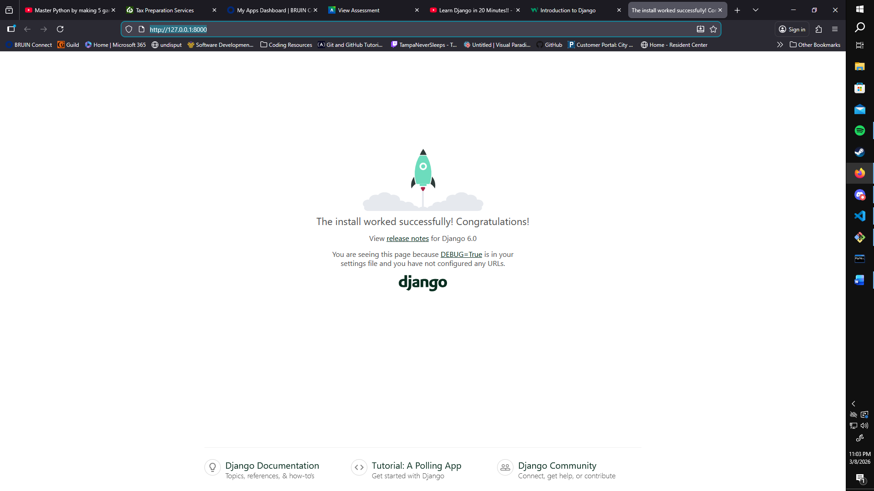
I could not get the page to return with the “Hello World!” text at all for some reason.

